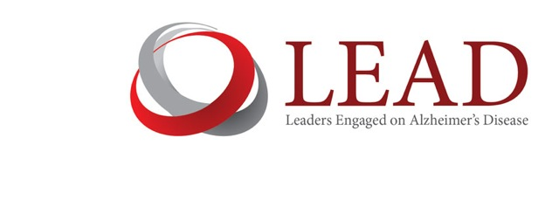
For Immediate Release Contact: Ian Kremer
December 23, 2015 571-383-9916
ikremer@leadcoalition.org

Leaders Engaged on Alzheimer’s Disease (LEAD) Statement on Hillary Clinton’s Alzheimer’s Plan

Washington, DC – Ian Kremer, Executive Director of Leaders Engaged on Alzheimer’s Disease (LEAD), released the following statement in response to Hillary Clinton’s plan to treat, prevent and cure Alzheimer’s disease by 2025.

“The LEAD Coalition welcomes Hillary Clinton’s plan to improve the quality of life for people living with Alzheimer’s disease and other dementias, strengthen support for caregivers, and accelerate funding for the National Institutes of Health research that will achieve the national goal of prevention, treatment, and cure by 2025.

The plan focuses on four critical elements, all top priorities for the LEAD Coalition: an increase in federal funding for Alzheimer’s and dementia research to $2 billion a year; a commitment to finding an effective prevention and treatment by 2025; attention to maximizing the quality of life for those living with dementia; and essential support for caregivers.

Secretary Clinton is the first presidential candidate of either party to propose a plan to battle dementia. We urge all others to come forward and do the same. The American people have a right to expect detailed and ambitious dementia action plans from every candidate for president – and every candidate or officeholder in Congress, the governorships, and state legislatures.

Over the past four decades, our nation’s leaders have put politics aside to make historic investments in science, public health, and social policy to turn the tide of once-hopeless and stigmatized diseases such as cancer, HIV/AIDS and heart disease. Secretary Clinton’s plan would build on bi-partisan Congressional leadership to emulate for dementia the strategy that has proven so effective in changing the trajectory of other health crises.

Overcoming dementia in all its forms is a public health, budgetary, economic, social, and ethical imperative for our country. We must bring dementia out of the shadows to confront both stigma and myth. We must deliver early and accurate detection and diagnosis. We must ensure diagnosed individuals and their families the education and support essential to maximizing their quality of life. We must fund both more science and better science so that, one day soon, dementia will be as rare as polio.”

About Alzheimer’s and dementia

Every four seconds, another person somewhere in the world is diagnosed with Alzheimer’s or related dementia. It is the only disease among the top 10 causes of death among Americans with no prevention, disease-modifying treatment, or cure. Alzheimer’s disease kills more than 500,000 Americans annually. More than five million Americans have dementia today, a number that is expected to almost triple, approaching 16 million, in the next few decades. Direct care costs of Alzheimer’s exceed those of cancer and heart disease. Total costs of Alzheimer’s exceed $200 billion annually, and 70 percent of this cost is shouldered by Medicare and Medicaid. If substantial progress is not made in stopping dementia, Medicare and Medicaid spending will reach $1.2 trillion in today’s dollars by 2050. The human toll exacted over the course of the disease on individuals, families, and communities is catastrophic.

###

Leaders Engaged on Alzheimer’s Disease (LEAD) is a diverse and growing national coalition of 80 member organizations including patient advocacy and voluntary health non-profits, philanthropies and foundations, trade and professional associations, academic research and clinical institutions, home and residential care providers, and biotechnology and pharmaceutical companies. LEAD is co-convened by the Alzheimer’s Foundation of America and UsAgainstAlzheimer’s. The coalition works collaboratively to focus the nation’s strategic attention on Alzheimer’s disease and related dementias and to accelerate transformational progress in care and support to enrich quality of life, detection and diagnosis, and research leading to prevention, effective treatment and eventual cure.

